I.T Project Management

Ben Callaghan
Project to compare Microsoft office 365 versus Google Docs and the implementation of the chosen format.

BSHC2B
X12112241
X12112241@student.ncirl.ie

IT Project Management
Office 365 versus Google Docs project

For this project I compared Microsoft office 365 for business versus Google Docs. Both of which are currently being used by cloud based companies for day to day business.
There was a large difference in options and cost in both and I was the I.T manager for the purpose of the project.
I chose the office 365 software based on the number of extra features compared to the Google Docs as with every I.T company the best software can save a lot of money in the long run.
The company I chose was a small IT business of twenty two people and due to this I chose office 365 small business premium.
With this option up to twenty five people have access to; business-class email, online conferencing, public website, file sharing and office online.
I have attached the relevant documents inside of this master document showing all of the steps taken to ensure the project would go ahead without delay and under budget.
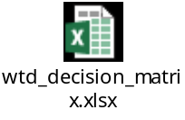
The weighted decision matrix was based off some key heading that I chose. These were cost, features, ease of use and ease of implementation.
- Cost: Due to the size of the business I chose small business premium. This had all of the features required for an annual cost of €124.80 per user per year. With a total budget of €4,500 the software cost was only €2,745.60.There was also additional costs due to being outside normal working hours and all of this was factored into the project.
- Features: Office 365 offered many more additional features compared to Google Docs as well as access to all of the office software offline. The current systems are using a baseline version of office 365 also.
- Ease of use: Currently the business is using office 2005 and there should be no issue for the business to change from the baseline to the premium version of office eliminating the time needed to train people to use new software.
- Ease of implementation: Since our I.T department have installed the previous software on all of the machines we are only allocating two days to change over twenty two machines. Also the new versions of office are backwards compatible with previous versions so there is little need to transfer or recreate files with the new version

Due to all of the criteria chosen office 365 scored a 90 with Google Docs only scoring a 62.5. That is why I chose office 365.

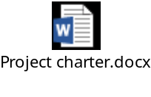
For the project charter I have listed information about myself, my team involved, success criteria, the budget and the approach that will be taken.

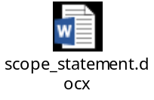
The purpose of the scope statement was to show the requirements of a successful changeover of the office upgrade, the justification of doing the changeover and the files involved in the project management role.
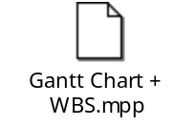
The WBS and Gantt chart were used to create the deadlines for each part of the project, the time needed for each action involved as well as giving me the ability to allocate the people required on the days needed after hours. This aided me with creating the overall budget also
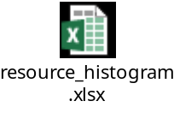
The resource histogram was used to show out of my team who would be needed throughout the entire changeover process. I also highlighted to cost’s that would be involved in doing the changeover outside of normal office hours at an increased pay rate for those involved.
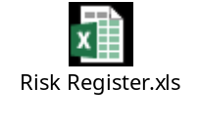
The risk register is used to highlight some of the risks involved in the software changeover, the impact if these where to happen, how to avoid them, who is in charge if they happen and what to do if they happen.

